# CU Robosub team

# 9/1/2018

# Merge Board

# 

# 

**Abstract** **3**

**Design Requirements** **3**

**Design Overview** **3**

Previous designs 3

**System descriptions** **4**

**System status** **5**

**Known Issues** **5**

**Appendix** **5**

# 

# Abstract

The merge board controls all input power to the sub from the two batteries. This board also balances the battery draw so that they drain equally and don’t start charging each other or dropping too quickly into dangerous low voltage states.

# Design Requirements

The merge board must:

* Receive input power and ground connections from the battery pods.
* Route proper connections for power and ground to the backplane.
* Not overheat from the amount of current passing through it.

# Design Overview

The batteries connect to the merge board through Molex CONNECTORS that can handle the large amount of current flowing through them. From there, the batteries are funnelled through high power mosfets from Infineon Technologies that can be turned off by commands from LTC4357s. The two LTC4357s perform OR operations to use the battery with the highest voltage, so that the sub will drain the fullest battery first. From there, the two battery inputs are merged into a 3oz copper plane and connected to the backplane for the other systems to use.

## Previous designs

Old merge boards used to combine both the kill switch/esc board and the merge board. This was to save space and cost, but due to oversights in copper thickness and design, these boards did not work as intended. Old desings had too small of copper necks from the battery connectors to the high power mosfets, so they would significantly heat up and potentially melt components off of the board. The old designs also used unreliable connectors to attach the battery leads which created worries for shorting and current throughput.

# 

# System descriptions

Shown below is the completed kill switch board design. Red represents top layer traces while blue represents bottom level traces. This board ended up being a two layer PCB with 3oz copper pours in order to route power and ground planes more efficiently and to significantly improve thermals. While it would have been better, 6oz copper was not used due to the clearances the LTC4357 and mosfet’s pads need to work properly. To compensate for this, large power and ground planes were used to dissipate the extra heat.

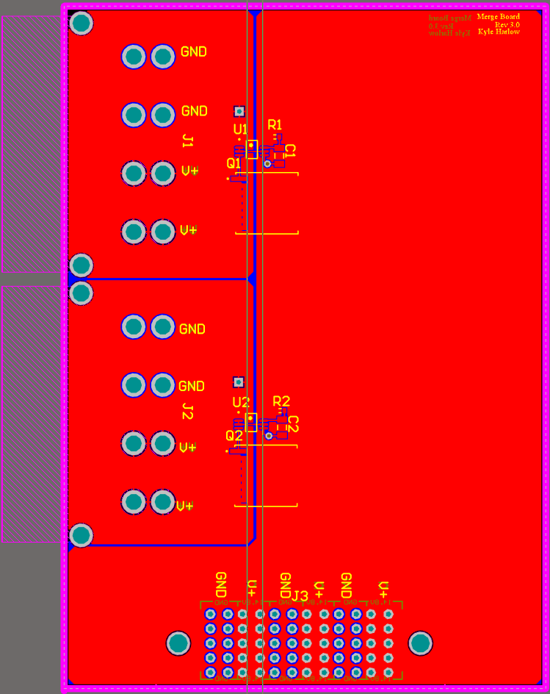

# System status

This system was completed and ran successfully on the 2018 sub Leviathan. No major issues were experienced after soldering.

# Known Issues

* This board is too tall. With the electrical rack, the clearance from this board to the acrylic tube is small enough to cause issues when taking the sub apart.
* The connector to the backplane cannot support the board completely and will get looser overtime.

# Appendix

Input Mosfets: <https://www.digikey.com/products/en?keywords=IPT004N03LATMA1CT-ND>

LTC4357: <https://www.digikey.com/products/en?keywords=LTC4357CMS8%23PBF-ND>

MiniFit Sr. Headers: <https://www.molex.com/molex/products/datasheet.jsp?part=active/0428204214_PCB_HEADERS.xml>